CAVE IN
TM
GAME PROGRAM
INSTRUCTIONS

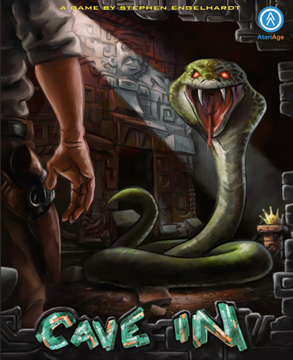


Game Story:

You are a fearless adventurer who has set out to locate and recover an ancient lost crown. The crown is priceless, and your years of research has placed it’s location in an underground cave recently discovered by an archaeological excavation team. Legend says the crown was broken into three pieces and hidden in this underground cave. The ancient civilization that hid the crown did not want it to be found, so they’ve made finding it and reassembling it a nearly impossible task. The crown is said to posseses strange powers, and can only be reassembled in the throne room, also located underground. Watch out for the traps that have been set for any adventurer who dares try to find the crown – poison arrows may shoot out of the walls, and giant boulders are released to roll you over! As you enter the cave, the entrance caves in and you realize that you're stuck - now you have two things on your mind, finding the lost crown and finding your way out!



As you start wandering through the cave, you'll encounter hordes of deadly underground creatures that will attack you along the way. Sometimes they will attack very aggressively, be careful! Luckily you’ve packed your trusty sidearm with you, and there’s an endless supply of ammunition. The enemies will sometimes drop a health pack (likely from other less fortunate adventurers!), which will give you a slight boost. There is also a pool of water hidden in the caves, if you find it and enter it you will regain all of your strength.

The walls of the cave are very unstable, so bumping the walls or firing your gun causes a slight tremor in the room. The locked caves were locked for a reason, they are very unstable. Shooting an enemy inside these caves starts a cave-in inside that room. Watch out for falling rocks!

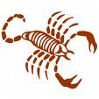

Inside the cave there are four locked gates. You'll have to search the cave to find the three individual keys that open the first three gates. To search a room for a key, simply bump into a cave wall. Search a room well, however, as all parts of the room with the key may not drop it. If there's a key in that room, you'll automatically pick it up and it will appear in your inventory. Each locked gate has it's own specific key. The fourth gate will unlock only in the presence of the three lost crown pieces. As you find the three pieces of the crown, the inventory status bar will show how many you've collected in the lower left corner of the screen. When you have all three, go to the final cave and find the throne room, which legend says has the power to bond the three crown pieces together. When you find the throne room, you'll find that it is protected by a guardian spirit that must be killed before you can restore the crown. It is the only enemy in the game that has hitpoints, and if you leave the room before he's been killed, the guardian’s health will recharge back to 100%.

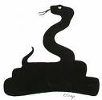
After you have killed the guardian, the crown will appear in the throne room. Run over it to pick it up. Now that you have what you came for, you need to run and find your way out of the mine! The original entrance to the mine caved in when you entered, so you’re going to have to find another way out. You'll have to search the cave for the hidden exit. Look very closely for the hidden exit, it’s very easy to overlook!

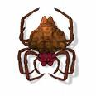

Once you reach the hidden exit and the crown is in your possession, you'll find the path is open to the outside, where you'll exit into the mountain valley and complete your quest.

You will be able to monitor your progress in the game with the status bar, located at the bottom of the screen.

Status Bars:

Status/Inventory Bar:
The status bar keeps track of your progress in the game. As you pick up crown pieces, they will appear on the bottom left. As you find the keys, the gun upgrade, and the completed crown, they will appear in your inventory. As you take damage from enemies, your health bar will decrease from right to left.

Crown Pieces Inventory Your Health

Guardian Status/Inventory Bar:
In the final battle against the guardian in the throne room, the crown piece status on the lower left will change to a health bar for the enemy. Your health status remains on the lower right. The guardian’s health meter runs in the opposite direction as yours.

Guardian’s Health Inventory Your Health

Areas of the Cave:

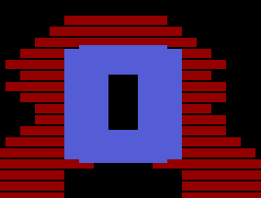 | Pool of Water :  Find the pool of water to recharge your health to 100%.

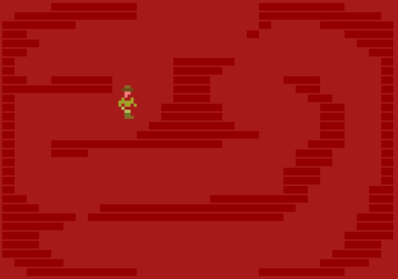 | Hot Lava!:  Lava Rooms have extremely hot cave walls that will injure you if you touch them. Walk very carefully through these rooms!

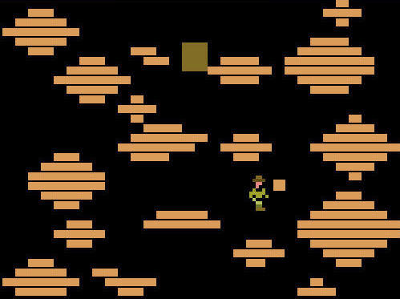 | Landslide!:  This is an area of fallen boulders. If you touch one of the stationary boulders, you’ll slide off! Beware of rolling boulders that move across the screen, as they will injure you.

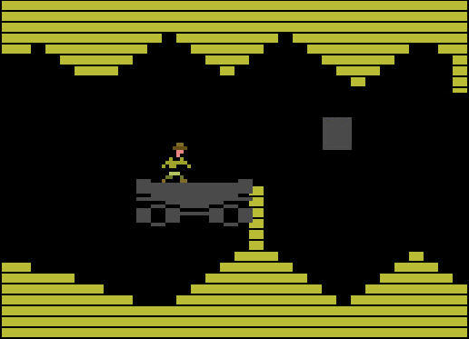 | Ride the Rail Car:  You may stumble upon the railcar during your quest, which once you jump on you have to ride the length of the track. You’ll move sideways along the path, with boulders dropping above you. If you run into the broken tracks along the way or get hit by a boulder, you will injure yourself. The boulder must hit you to do any damage, it will simply bounce off the rail car.

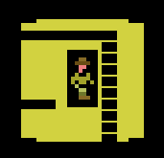 | Lights Out!  There is one dark, narrow passageway that you’ll have to find your way through in order to reach one of the locked caves. You’ll be carrying a light that lets you see a short distance all around you. You can’t use your gun in the mine shaft, but thankfully there are no enemies to get in your way. If you are carrying the shield, you can keep it inside the mine shaft, but it will be invisible. The same rule applies, if you touch a wall you will drop it.
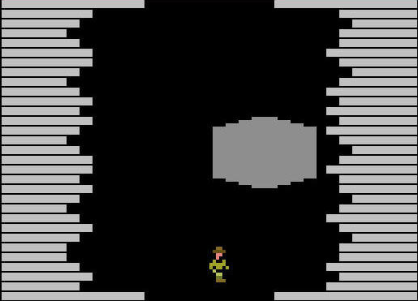 | Falling Boulders:  There are several boulder rooms in the mine. Avoid the boulder as it rolls toward you – it will do a lot of damage if it hits you!

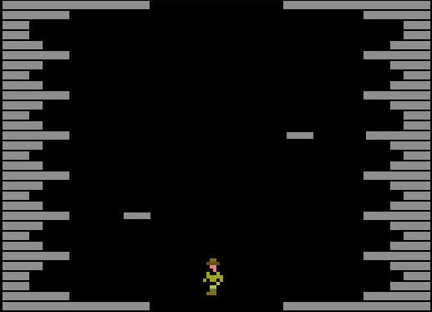 | Poison Arrows:  You’ll run across a few of these traps in the mine. Watch out for the deadly arrows that shoot from both sides of the room.

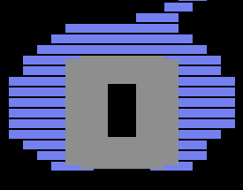 | Underground Tunnels:  These operate like warp zones, you’ll enter one of the tunnels and reappear at the other end of the tunnel, which is on the other side of the cave.

One of the caves requires that you have all three crown pieces, at which time it will automatically unlock. It has no key. | Locked Caves:  There are four locked caves in the mine. Three of them contain the crown pieces, and the fourth contains the throne room where you bring all of the crown pieces. These caves are very unstable, shooting enemies will cause a rockslide. Be very careful!
  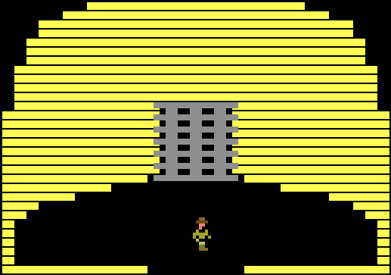 | 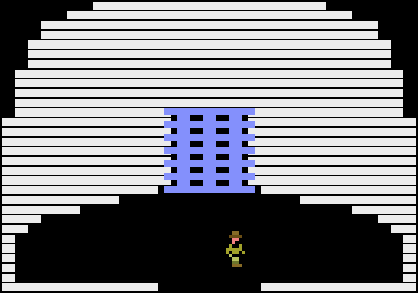
  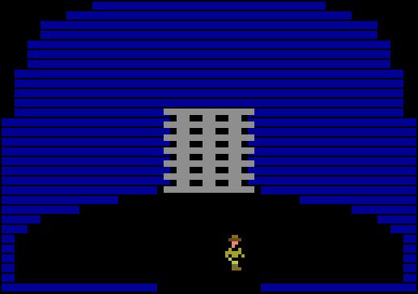 | 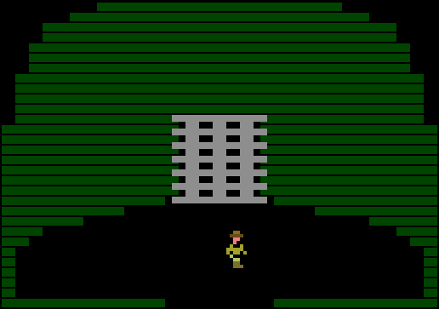

Your Health

You start with 80 units of health, represented by 8 blocks on the on-screen health meter. One unit of health (1 block on the screen) represents 10 points of health. For every 10 health points you lose, one block will disappear on the screen.

Here is how the health system works:

- Hit by an enemy: -1 Point
- Hit by an obstacle (rock, arrow, boulder): -1 Point for each second you're in contact with the obstacle
- Move to a different room when your health is at 30 points or less (Game 2): -1 Point
- Move to a different room (Game 3): -1 Point
- Pick up a health pack: Recharges current block of health points to full (no on-screen change to health meter).
- Enter Pool of Water: Recharges your health units to 100%, status bar returns to full on-screen.

Difficulty Options

Cave In offers three levels of difficulty. The level select screen appears each time you start a new game. Choose your level by pressing up or down on the joystick, and then press fire to begin the game.

Here are the default options, which are standard in all difficulty levels:
- When you get down to 3 blocks of health, your adventurer gets tired and will move more slowly.
- Enemies will die after attacking you 7 times.
- You will drop your gun after losing a health block. Enemies will sometimes drop a gun, or you can find one hidden in the caves.
- The shield is available in all game levels.

Game 1 - Beginner
- Enemies move at normal speed and never have a fast attack
- No health reduction when changing rooms
- Keys are always hidden in the same rooms
- You start out with your gun, and you will never lose it.

Game 2 - Intermediate
- Enemies move at normal speed with occasional fast attacks
- 1 point health reduction when you change rooms only after you are down to 3 health blocks left
- Key locations are randomized
- You start out with no gun - you will have to find it.

Game 3 - Advanced
- Enemies move at top speed all the time
- 1 point health reduction when you change rooms at all times
- Key locations are randomized
- You start out with no gun - you will have to find it.
- Falling rocks in the locked caves will fall twice as fast

Objects/Inventory Items

Here is a list of items you’ll find in the mine.

1 2 3 | Keys:  You’ll need to collect three keys to enter the locked caves. Each key corresponds to a specific locked cave.  1. Spider Key  2. Evil eye Key  3. Skull Key

 | The Switch:  Pushing this switch must do something, but it’s use remains a mystery.

  or   |  | Health Recharge Pack:  Sometimes an enemy will drop a health pack after you kill it. Pick it up to recharge your hit counter. What’s a hit counter? Well, you get 10 enemy hits per health bar block - it resets the hit counter 0, but does not change the length of the health bar on the screen.
 |  | The Shield:  When you're holding it, enemies cannot harm you. You will drop the shield when you touch a wall or when you enter a locked cave entrance room. The shield will return to it's original location when dropped. You can keep it in the invisible maze rooms, but it too will be invisible. The shield can also be used to kill enemies when you don’t have a gun.
 |  | The Crown:  After you defeat the guardian, you can pick up the completed crown, which will display in your inventory. Now you have to find your way to the exit!
 | The Gun:  The gun is in a hidden location somewhere within the cave.

That should be all you need to know to complete your quest for the crown. There may be other secrets to be found, so explore every corner of the cave! Good luck on your adventure!

